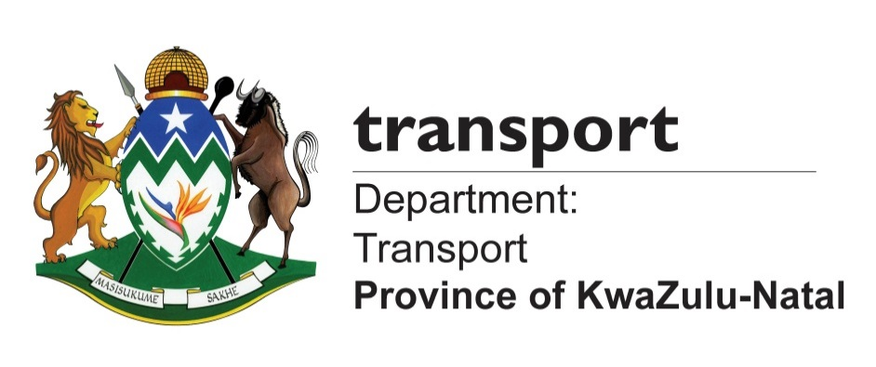

MEDIA ADVISORY

Thursday, 30 November 2017

PROVINCIAL GOVERNMENT TO HOST MEMORIAL LECTURE ON DUMISANI MAKHAYE AHEAD OF OFFICIAL OPENING OF DUMISANI MAKHAYE DRIVE

The Provincial Government will this weekend celebrate the life of Dumisani Makhaye through the official opening of the Dumisani Makhaye Drive (Main Road 577) which will be officiated by President Jacob Zuma.

As part of the build up to the official opening, the Provincial Government will also hold a memorial lecture on Dumisani Makhaye that will be addressed by the Leader of Government Business and MEC for Economic Development, Tourism and Environmental Affairs, Sihle Zikalala and other alliance leaders.

This will be preceded by a wreath laying ceremony at the Redhill Cemetery at the gravesite of the late Dumisani Makhaye with the Makhaye family.

The road is being named after the late struggle hero, who also served in various capacities as MEC in the KwaZulu-Natal Provincial Executive Council.

The naming of the road is part of provincial government’s Roads Naming and Renaming Legacy Project which is aimed at naming and renaming roads network infrastructure which will help communities to reclaim their historical legacy, pride and heritage by giving new, meaningful names to new and existing provincial roads and bridges.

The completion of the R1, 3 billion road infrastructure project – the biggest in the last five years – epitomises government’s service delivery excellence. The road connects among others, the communities of Newlands, KwaMashu, Inanda, KwaDabeka, Clermont and Pinetown. It is also a new alternative route to King Shaka International Airport for traffic coming from the Pietermaritzburg and Pinetown areas, which will now ease traffic congestion on the N2/N3 interchange.

Details are as follows:

Wreath laying ceremony:
Date: 1 December 2017
Venue: Redhill Cemetery
Time: 15h00

Memorial Lecture
Date: 1 December 2017
Venue: KwaMashu Indoor Sports Centre
Time: 17h00

*Reminder: Media attending the main official opening of the Dumisani Makhaye Drive to be held on 2 December 2017 must send their ID/Passport numbers and other details for accreditation to Mandisi Mhlongo on 0828059072 or Mandisi.Mhlongo@kzntransport.gov.za or Akhona Dlamini on 0828059072 or Akhona.Dlamini@kzntransport.gov.za
Ends.

Media contacts:
Mluleki Mtungwa: 0609741140 / mluleki.mtungwa@kzntransport.gov.za
Kwanele Ncalane: 0728031462/ 0796995755/ Kwanele.Ncalane@kzntransport.gov.za
Nathi Sukazi: 0810180518/ Nathi.Sukazi@kzntransport.gov.za

Website: www.kzntransport.gov.za
Twitter: @KZNTransport
Facebook: www.facebook.com/kzntransport

